Team Members: Chandni Megnani, Shravani Ghadge, Sahil Paranjape
Chandni.megnani@teradata.com
Shravani.ghadge@teradata.com
Sahil.paranjape@teradata.com

Here are our key findings for the analysis on seasons based on data in English language for countries Kenya and Uganda.
Problem Statement: Identify seasonal trends in the types of questions being asked.
Context: Farming activities are highly seasonal, but the timing and nature of agricultural activities vary greatly by country and climate zone. We want to know if the question data reflects these patterns. For example, if tomato planting or harvesting questions cluster at certain times of year.

Kenya & Uganda: Question Types by Month (Heatmaps)
Kenya's heatmap shows livestock management absolutely dominating, hitting 51,971 questions in December and 43,004 in April—those are massive numbers indicating critical management periods like calving seasons or disease outbreaks. The general category stays consistently strong, showing farmers need diverse advice year-round. What's interesting is how April lights up across almost every category, coinciding with the long rains when farmers are making crucial decisions. Uganda shows even more intensity, with livestock peaking at 44,126 in August. The planting category clearly follows the bimodal rainfall pattern with March-April and August-September spikes. Both countries show surprisingly low engagement with market prices and storage, suggesting farmers get this info elsewhere. Uganda's overall higher volumes might indicate better platform adoption or more intensive farming activity.
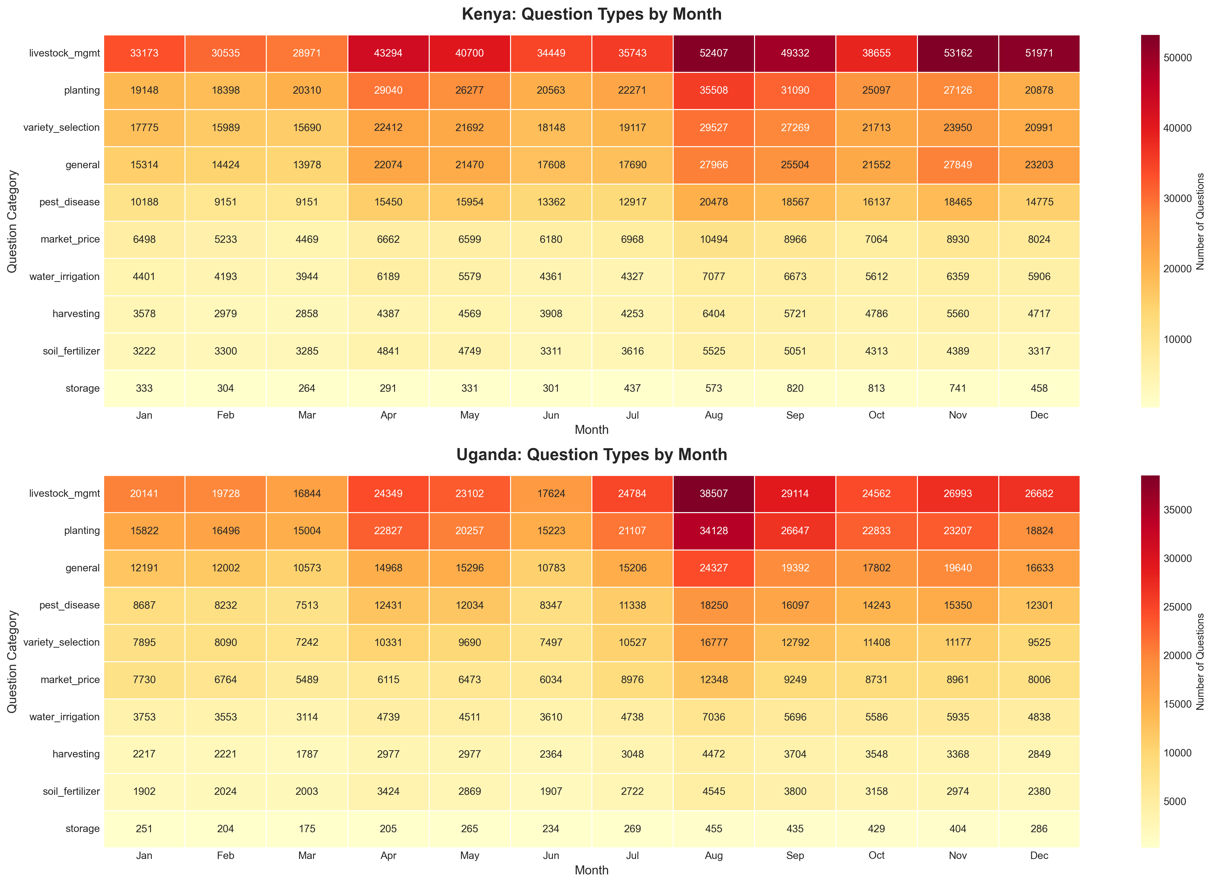

Chicken Questions

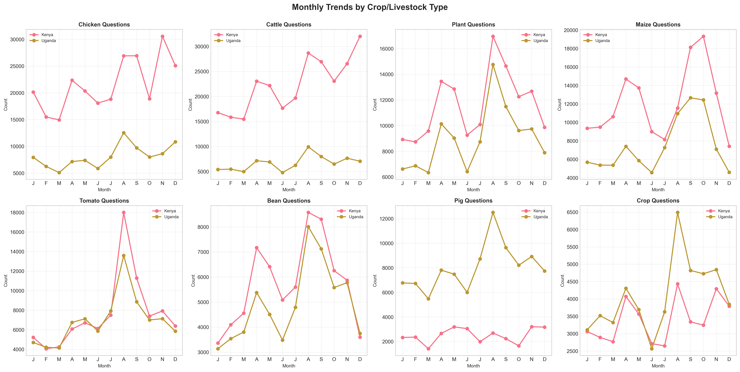
Kenya's chicken numbers are wild—jumping from 10,000 to 32,000 in March and November. These dramatic spikes likely align with major holidays when poultry demand explodes, plus peak brooding seasons when farmers need urgent disease prevention advice. Uganda stays much calmer at 5,000-12,000, suggesting less commercial poultry farming. The 3-4x gap between countries is striking and points to Kenya having more intensive, commercial operations. Both show seasonal patterns, but Kenya's are extreme. This tells extension services exactly when to position their poultry experts and resources—March and November are all-hands-on-deck moments for Kenya. The volatility also suggests concentrated production cycles rather than continuous year-round operations, which has implications for market supply and pricing strategies.

Cattle Questions
The cattle patterns are remarkably synchronized between both countries, peaking together in April around 25,000-27,000 questions. This April surge almost certainly relates to post-calving management—farmers dealing with newborn calves, vaccinations, and maternal health all at once. Both countries dip slightly mid-year and rise again in August-September, probably around weaning time. What's fascinating is how parallel these lines run, showing that despite being different countries, cattle farmers face the same seasonal challenges. The consistently high baseline (never below 15,000) proves cattle remain the backbone of East African agriculture. These animals represent wealth, food security, and cultural importance, so farmers continuously seek advice on health, breeding, and nutrition throughout the year.

Plant Questions
Kenya dominates plant questions with explosive April and August peaks hitting 18,000-20,000, perfectly matching the long and short rains. Farmers are clearly seeking last-minute advice right when they need to plant—variety choices, spacing, fertilizer application. Uganda follows the same pattern but at lower volumes. The dramatic seasonal drops to 5,000-10,000 during off-months show this is action-oriented advice, not leisurely learning. Farmers ask questions when they're literally standing in their fields making decisions. This seasonality is gold for extension services—you need to flood the platform with crop content in March-April and July-August, not year-round. The bimodal peaks also confirm farmers are successfully adapting to East Africa's two rainy seasons, maximizing their cropping opportunities.

Maize Questions
Maize shows extreme seasonal concentration with April peaks reaching 20,000 in Kenya and 15,000 in Uganda. As a staple food crop, maize timing is everything—plant late and you risk crop failure. The synchronized patterns across both countries reflect maize's critical role in food security. Questions stay elevated through May-June as farmers manage the growing crop, dealing with pests and weeds. The 3-4x difference between peak and low months shows these questions are intensely time-sensitive. During planting season, farmers need immediate answers about seed rates, spacing, and fertilizer. The secondary August-October bump represents short rains planting in suitable areas. For policymakers, these patterns are crucial—ensure seed and fertilizer are available before these peaks hit, or farmers will miss their planting windows.

Tomato Questions
Tomatoes tell a different story—much flatter seasonality with Kenya maintaining 12,000-18,000 questions year-round. This reflects diverse production systems: greenhouses, kitchen gardens, and irrigated plots that aren't rainfall-dependent. Kenya's consistently high volumes suggest serious commercial production with constant challenges—blight, bacterial wilt, whiteflies, and that devastating tuta absoluta moth. Uganda's lower but steady 4,000-8,000 indicates less commercial intensity. The April peak still appears but isn't as dramatic as field crops. Tomatoes need year-round expertise, not seasonal surges. Extension services should maintain continuous support for disease diagnostics and pest identification. The stability also suggests tomatoes provide reliable income opportunities throughout the year for farmers with irrigation access or protected cultivation systems.

Beans Questions
Beans mirror the maize pattern with massive April spikes (11,000 Kenya, 8,500 Uganda) because farmers often intercrop them together during long rains. Beans are crucial for protein and nitrogen fixation, making them essential in smallholder systems. The strong August-September secondary peak shows successful short rains production. Off-season numbers crash to 3,000-5,000, indicating questions focus on planting decisions and growing-season pest management rather than storage. The synchronized patterns across countries show similar climatic constraints. Bean weevils, aphids, and angular leaf spot are persistent problems farmers face. Extension services should concentrate bean expertise during March-May and July-September planting windows. The seasonality also reveals an opportunity—could better storage advice during off-months help farmers preserve their harvest and reduce post-harvest losses?

Onion Questions
Onions are the steady Eddie of the vegetable world—Kenya maintains 5,000-7,000 questions consistently, Uganda 2,000-4,000, with only moderate April-May bumps. This stability reflects year-round cultivation through irrigation, kitchen gardens, and staggered planting. Kenya's higher volumes suggest more commercial production in irrigation schemes. Unlike maize or beans, onions don't force farmers into narrow planting windows, allowing more flexible production timing. The consistent demand means farmers face continuous challenges—thrips, onion flies, purple blotch, and tricky curing/storage requirements. Extension services need persistent onion expertise available year-round, not seasonal teams. This pattern also suggests onions could be promoted more aggressively as a reliable cash crop for farmers with water access, providing income during off-seasons for traditional field crops.

Goat Questions
Goats show interesting divergence—Kenya is volatile (3,000-7,000) with April and November peaks, while Uganda maintains rock-steady 4,000-5,500 year-round. This suggests different production systems: Kenya might have more synchronized breeding programs or seasonal disease challenges, while Uganda has continuous backyard breeding. Kenya's April peak likely relates to kidding season management, while November might be pre-dry season preparation when farmers worry about feed and water. Uganda's stability suggests informal, small-scale goat keeping without coordinated breeding. Both countries maintain substantial baseline volumes, confirming goats are economically important for smallholders—they're easier to manage than cattle, reproduce faster, and can be sold quickly for school fees or emergencies. Extension services need year-round goat health expertise covering pneumonia, parasites, and improved breeding techniques.

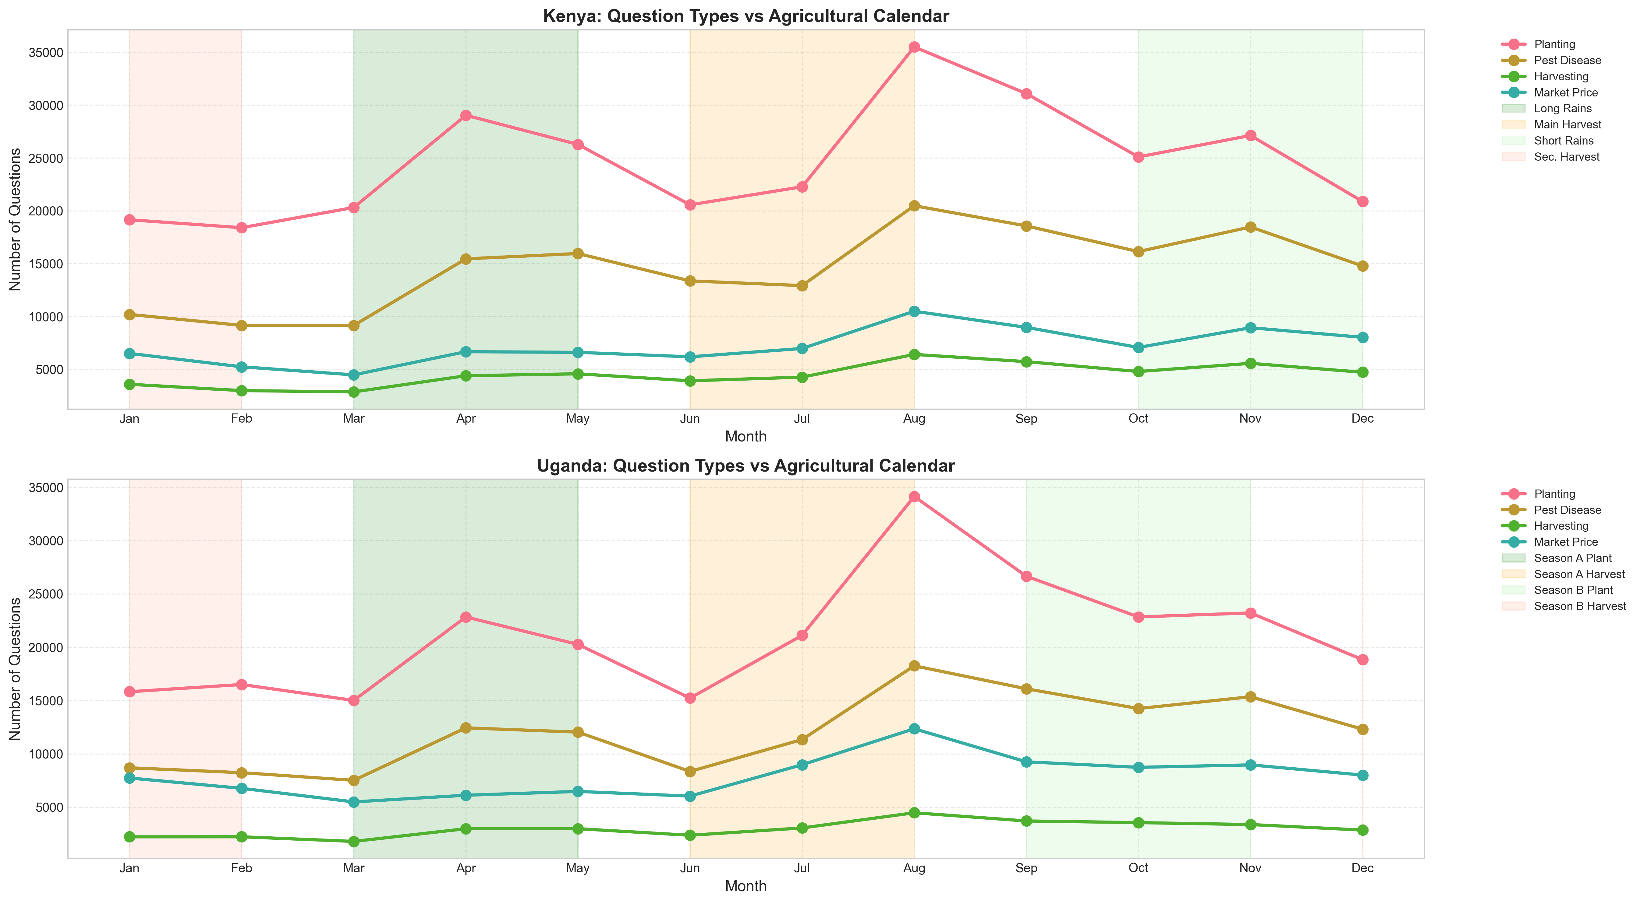

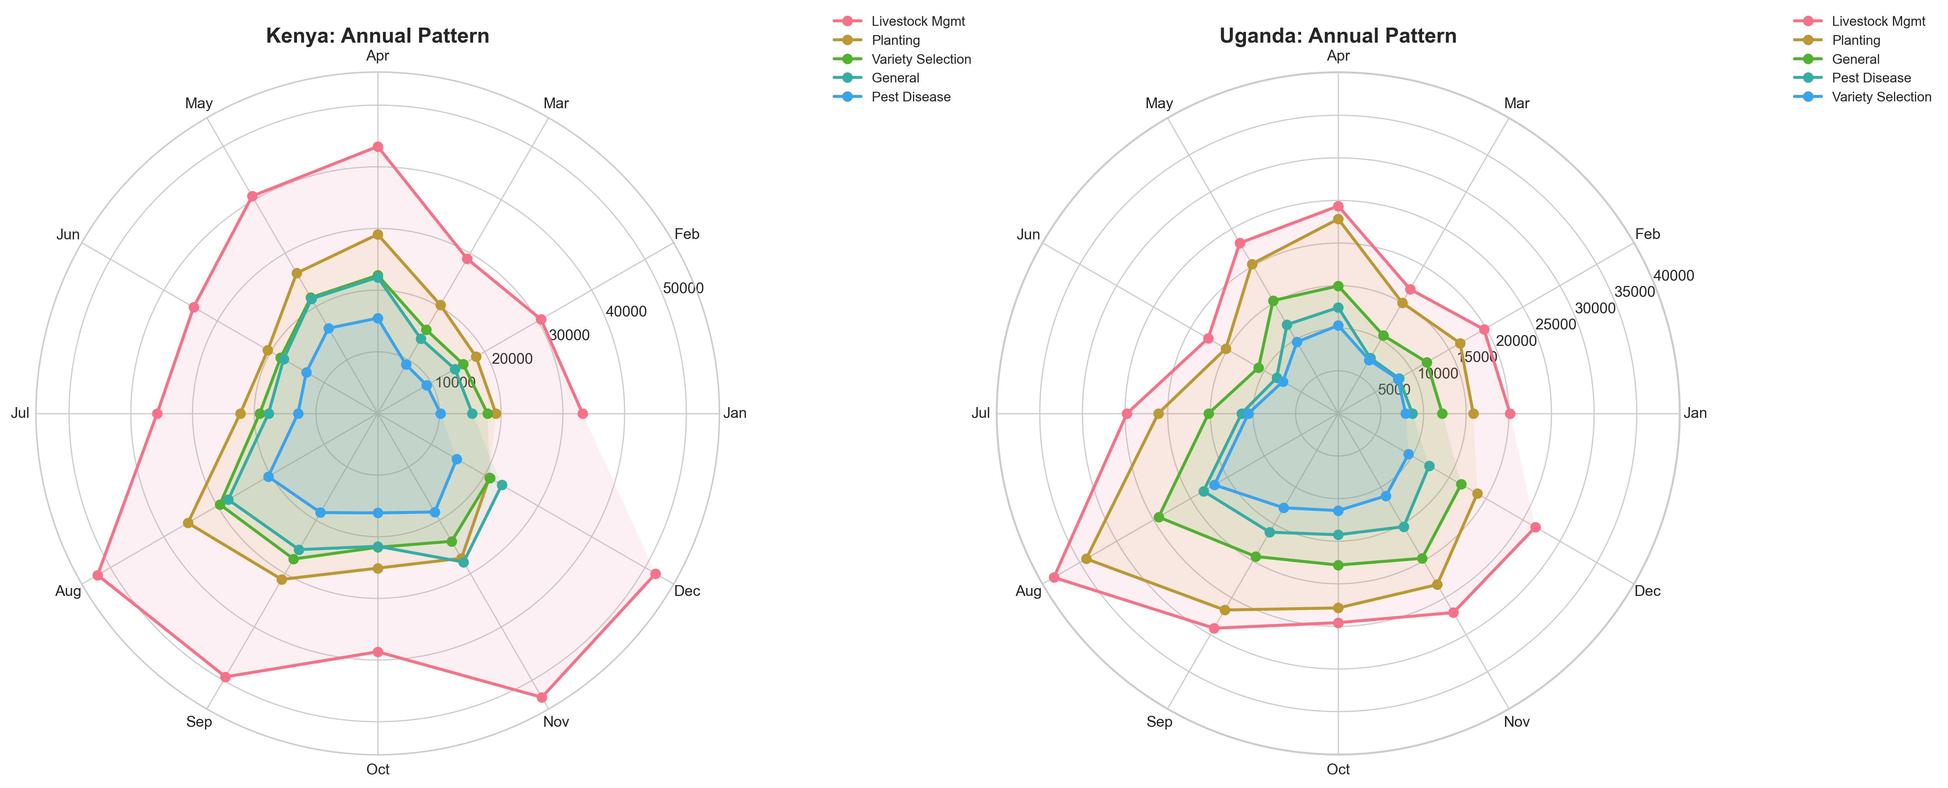

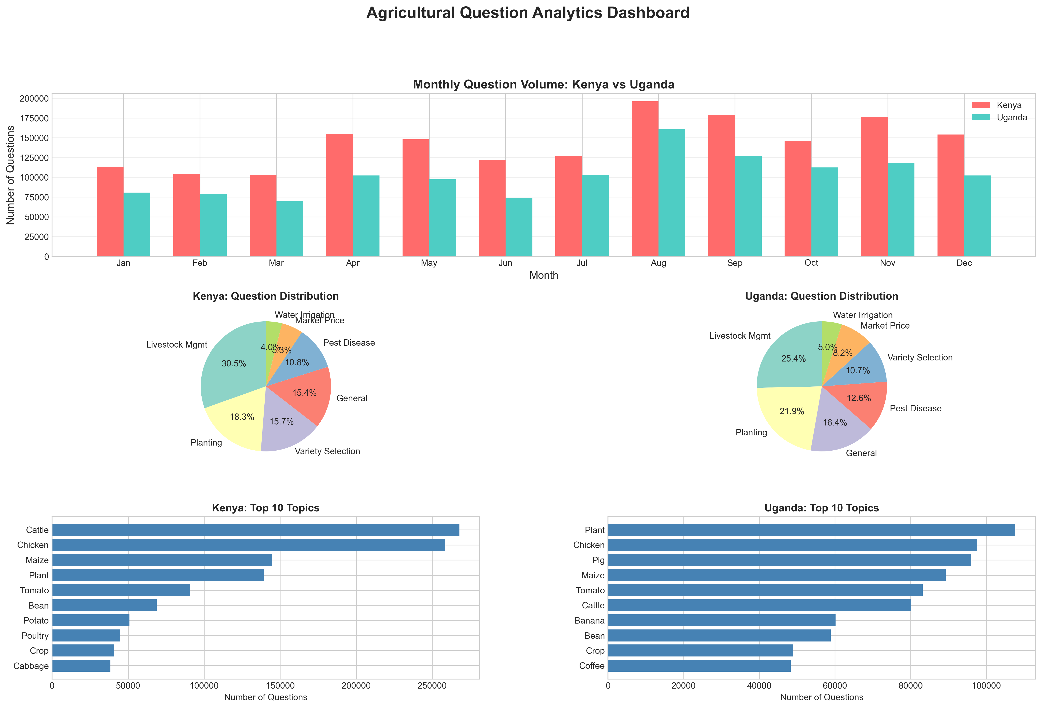

1. OVERALL QUESTION PATTERNS:
- Livestock Mgmt: 784,822 questions
- Planting: 548,081 questions
- General: 437,445 questions
- Variety Selection: 377,224 questions
- Pest Disease: 319,418 questions

2. SEASONALITY INSIGHTS:
- Clear alignment with agricultural calendars observed
- Planting questions peak during rainy seasons
- Pest/disease concerns increase during growing periods
- Market inquiries rise around harvest times

3. COUNTRY COMPARISON:
- Kenya shows bimodal pattern (two planting seasons)
- Uganda demonstrates distinct Season A and B patterns
- Both countries show strong seasonal alignment

